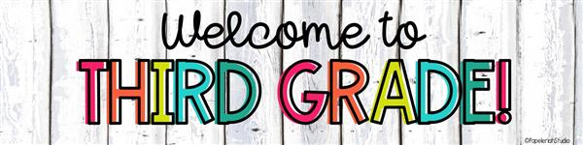

Hello, my name is Ms. Swick. I am so excited to be your child’s teacher! This will be a year filled with learning, making new friends, and exploring the arts. This will be my 11th year teaching in Pinellas County, and I am so excited to be teaching 3rd grade at Perkins again!

**Below are several important points to remember so that your child has a great 3rd Grade experience:**

1. Breakfast and Lunch is **FREE** for all students.
2. Bring a backpack to school each day labeled with your child’s name.
3. Water bottles or containers are recommended and need to be labeled with a name please.
4. If you wish, to donate dry snacks for the class it will be greatly appreciated! Snacks may be cereal, crackers, pretzels, goldfish, graham crackers, etc. *(Please avoid snacks with peanuts/peanut butter due to allergies).*
5. Attached you will find the recommended supply list- understand that most supplies will be shared as a class.

At ‘Meet the Teacher,’ your child will bring home school forms that need your immediate attention. Please make time to fill out and return required forms in a timely manner.

Please feel free to contact me throughout the school year. I want to be your partner in supporting your child in any way. **Focus** is the easiest and fastest way to contact me, however, feel free to email me at any time as well at swicke@pcsb.org. I look forward to meeting you soon. It’s going to be a great year!

All my best,

Ms. Swick